Photo challenge
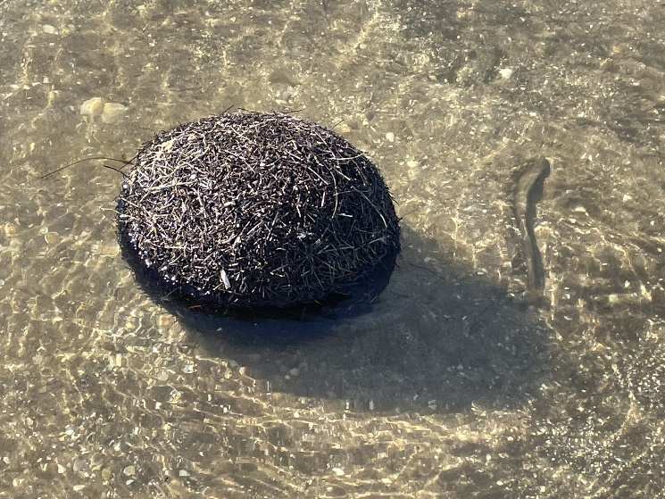
Calling all amateur photographers with a passion for Victoria’s spectacular coastline!

Get outdoors, get snapping and enter your photos into the Summer by the Sea 2022 photo challenge.

Your entry(ies) must showcase one of the following themes:
- Connecting with coast
- Creatures of the coast
- Coastal colours

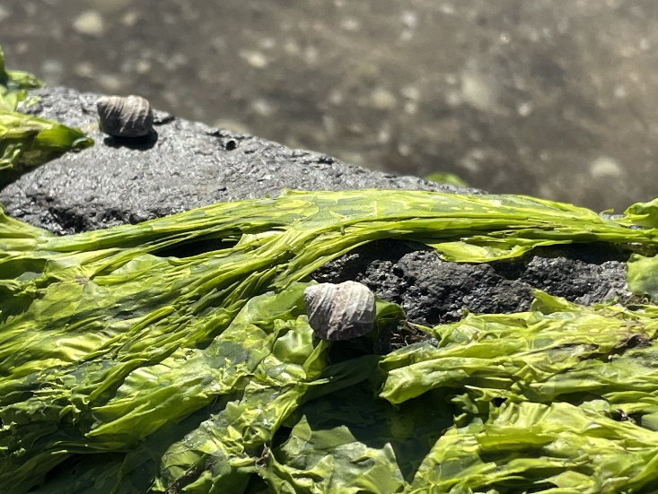
The important details:

- The challenge runs from 3^{rd -} 25th January and is open to all ages

- Participants can enter up to three photos

- Whilst exploring the coastline and capturing your images, please ensure not to disturb wildlife or their habitats

- Images must be:
  - Taken within Victoria
  - JPEG format

How to enter:

- Share with us on social media by tagging the Summer by the Sea | Facebook or Instagram (@summerbythesea_vic) and use the hashtag #SBTSphotochallenge
- Email your photo to Coastcare.victoria@delwp.com.au and make the subject "SBTS photo challenge - *your chosen theme*
Choosing the best:
The top photos under each theme will be chosen by the Coastcare Victoria team, announced on January 28th 2022 and will feature on our website.

