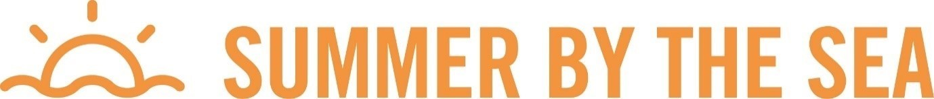

Online Facilitator Listening Post

Join the Bellarine and Surfcoast Coastcare Victoria Facilitator Madi Cassie for a fun and informative catchup

- Enjoy a viewing of the short video ‘Volunteering for Threatened Flora’ presented by Naomi Wells from Bellarine Catchment Network (filmed by Grassland Films)
- Hear about things happening in the Bellarine and Surfcoast regions
- Learn about support provided by Coastcare Victoria: grants, training, networking
- Meet some other like-minded people and volunteers from your region
- A chance for an informal Q&A session
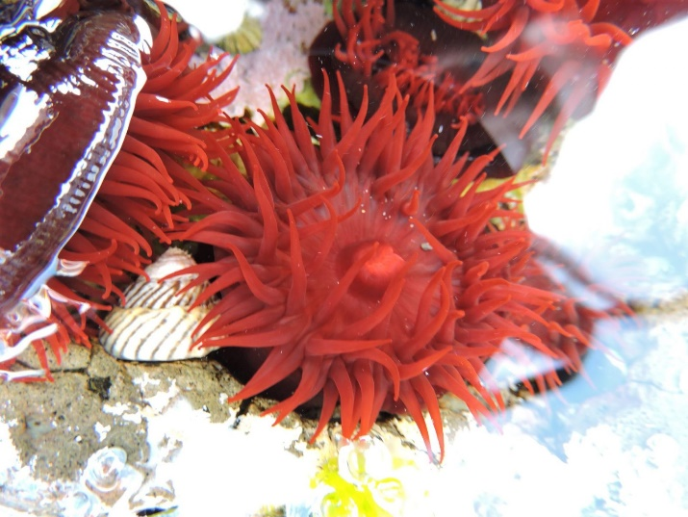

The important details

- Monday 24 January 2022
- 11:00 – 12:00
- Registration booking

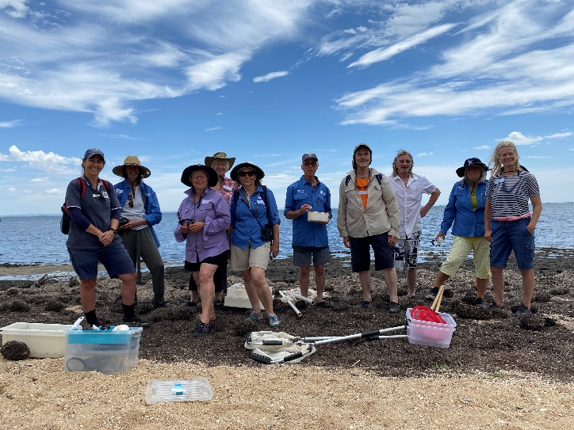
Highlighting our locals
Bellarine Catchment Network (BCN) are an environmental non-profit on the Bellarine Peninsula working to protect and enhance the environment. They support and educate groups across the region.

Image: Volunteers from Clifton Springs Curlewis Coastcare Group with educators from the Victorian Fisheries Authority at an education day organised by BCN at the beach.

