Online Facilitator Listening Post

Join the East Gippsland Coastcare Victoria facilitator Bethany Hunting for a fun and informative catchup

- Enjoy a viewing of the short video ‘Turning the Tide With Marine Mammal Conservation’ presented by the team from the Maine Mammal Foundation
- Hear about things happening in the East Gippsland region
- Learn about support provided by Coastcare Victoria: grants, training, networking
- Meet some other like-minded people and volunteers from your region
- A chance for an informal Q&A session
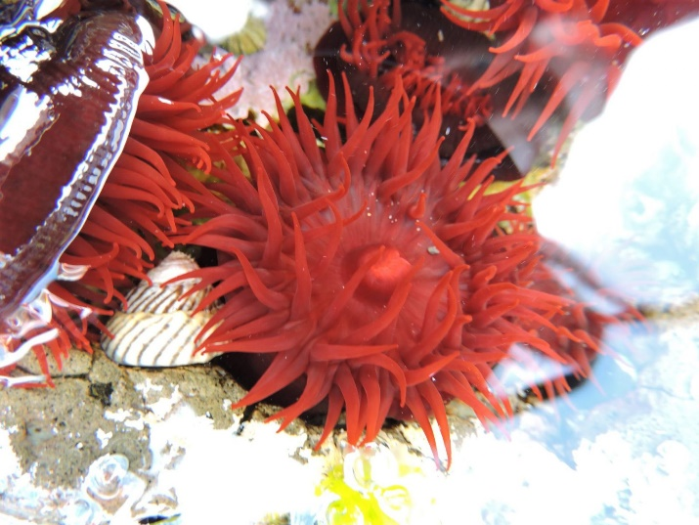

The important details

- Thursday 20 January 2022
- 14:00 – 15:30
- Registration booking

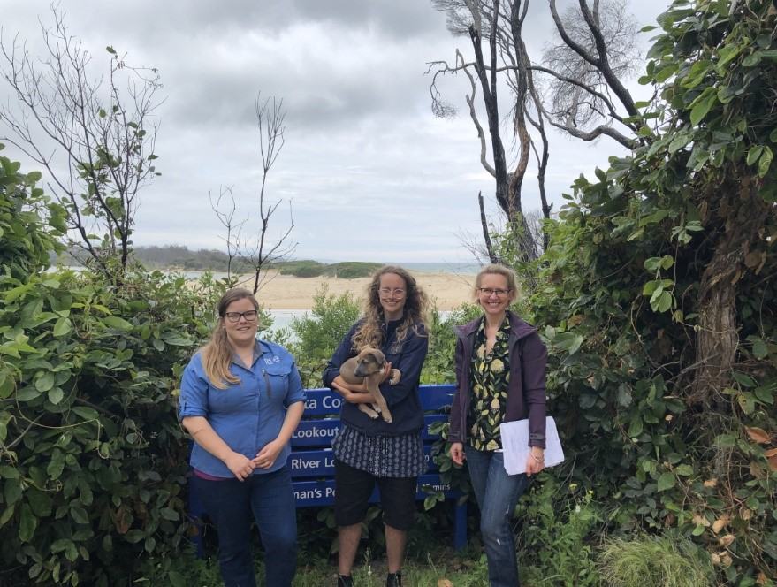
Highlighting a local group
Bethany Hunting (left) with Brodie Gaudion (middle) and Paris Brooke (right) from Mallacoota Sanctuary Youth Group on site at Betka Beach.
In 2020 the Sanctuary Mallacoota Youth Group was awarded a Coastcare Victoria Community Grant, under Stream 2: Strengthening Our Volunteer Groups. This project sought to foster the development, understanding, interest and connection that the youth of Mallacoota have to their unique patch of coastline

