Online Facilitator Listening Post

Join the Port Phillip and Westernport facilitator Ellie Morrow for a fun and informative catchup

- Enjoy a viewing of the short video ‘Balcombe Estuary Eel Migration’ presented by Suzanne Ryan from the Balcombe Estuary Reserves Group (filmed by Grassland Films)
- Hear about things happening in the Port Phillip and Westernport region
- Learn about support provided by Coastcare Victoria: grants, training, networking
- Meet some other like-minded people and volunteers from your region
- A chance for an informal Q&A session

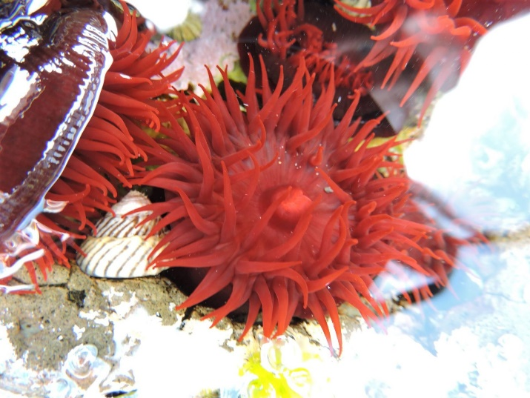
The important details

- Thursday 20 January 2022
- 10:00 – 11:00
- Registration booking

Highlighting a local group
The Balcombe Estuary Reserves Group (BERG Mt Martha) is a friends group formed to preserve and restore the unique ecology of the Balcombe Estuary and Reserves located on the Mornington Peninsula. Doing weeding, planting, monitoring, engagement and much more. You can learn more about them in their regular newsletter ‘The Creek’. Image: Barb Thraves & Liz Barraclough removing Polygala at a Sunday working bee

